Safety knows no boundaries
B&R simplifies machine-to-machine safety communication
B&R now makes it easier than ever to implement safety communication between machines and machine modules. An update to its mapp Safety software now enables programmable safety functions to be used across complex manufacturing systems with virtually no additional effort – greatly reducing the time spent implementing systemwide safety functions.

To achieve Industry 4.0 functionality, modern manufacturing equipment needs to be densely interconnected. Devices, machines, lines and cells must all communicate with each other safely and reliably. Implementing a systemwide emergency stop is one thing – more nuanced, intelligent safety reactions quite another. Until now, it has often been the case that each different configuration of a manufacturing system requires development and verification of a corresponding safety application.
Easy implementation with mapp Safety
This added overhead is no longer necessary. The software components in B&R's mapp Safety package significantly improve communication between safety controllers and greatly simplify safety applications. New system components can be added at any time without having to rewrite the safety application. To put a new component into operation, all the operator needs to do is adjust a few parameters on the HMI screen.
Direct data exchange
With B&R safety controllers, users can configure up to 150 communication connections to other safety controllers. Even the especially compact SafeLOGIC-X controllers support these functions and can be incorporated in machine-to-machine networks.
Safe communication
Data is transmitted using the openSAFETY protocol via POWERLINK or UDP. Any proven cable or wireless technology can be used as the transmission media.

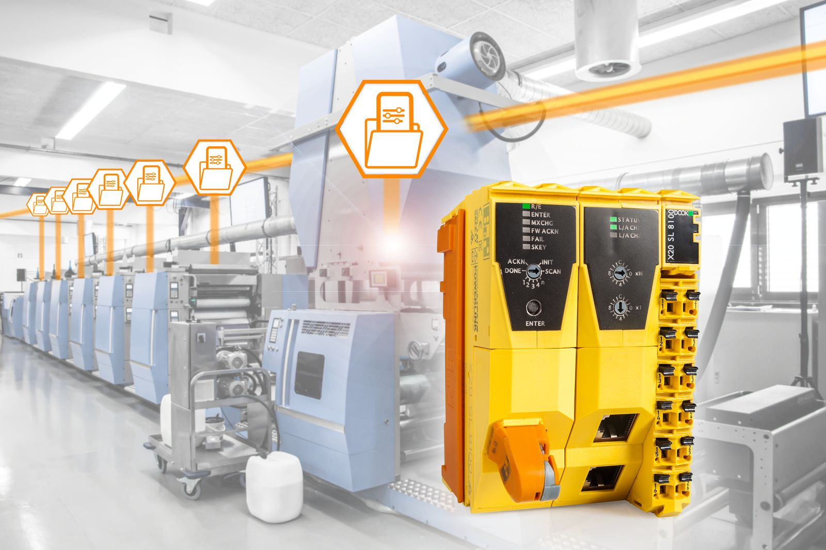
With safe and flexible communication between safety controllers, B&R brings the advantages of programmable safety to systemwide safety functions.

About B&R
B&R is an innovative automation company with headquarters in Austria and offices all around the world. On July 6, 2017, B&R became a business unit of the ABB Group. As a global leader in industrial automation, B&R combines state-of-the-art technology with advanced engineering to provide customers in virtually every industry with complete solutions for machine and factory automation, motion control, HMI and integrated safety technology. With Industrial IoT communication standards like OPC UA, POWERLINK and openSAFETY as well as the powerful Automation Studio software development environment, B&R is constantly redefining the future of automation engineering. The innovative spirit that keeps B&R at the forefront of industrial automation is driven by a commitment to simplifying processes and exceeding customer expectations.
For more information, visit www.br-automation.com.

