Machine vision gets four times faster
HALCON 20.11. and quad-core processor boost machine productivity
B&R has dramatically accelerated execution of all types of machine vision applications. A new quad-core processor and just-in-time compiler help the Smart Sensor complete vision tasks up to four times faster. Machine builders can substantially increase the output of their machines without having to use expensive dedicated PCs for machine vision.
With the latest Steady version of the HALCON library, B&R's machine vision system now has a just-in-time (JIT) compiler that generates executable machine code when the application is loaded, rather than interpreting it later at runtime.
Available via software update
The JIT compiler substantially reduces the time it takes to execute a variety of vision functions. For measurement tasks, the savings can be in excess of 75% – meaning they are completed in a quarter of the time. Access to the new JIT compiler comes with a simple software update.
Cut cycle times in half
Multi-core capable image processing algorithms also benefit from the quad-core processor in the new Smart Sensor. The increased computing power makes it possible to cut the cycle time of matching applications nearly in half.

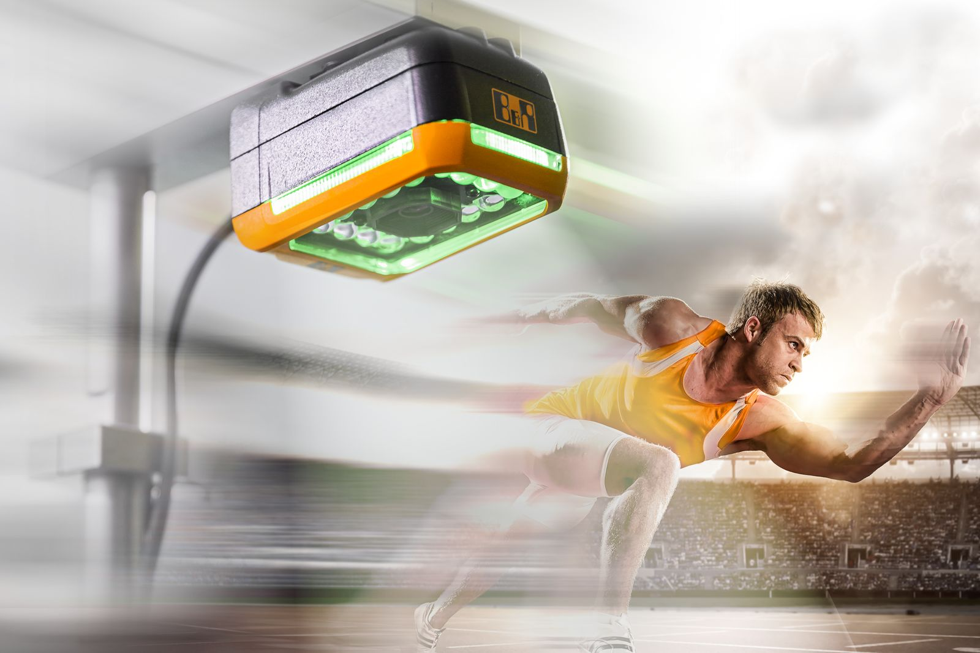
B&R's Smart Sensor now completes vision tasks up to four times faster.

About B&R
B&R is an innovative automation company with headquarters in Austria and offices all around the world. On July 6, 2017, B&R became a business unit of the ABB Group. As a global leader in industrial automation, B&R combines state-of-the-art technology with advanced engineering to provide customers in virtually every industry with complete solutions for machine and factory automation, motion control, HMI and integrated safety technology. With Industrial IoT communication standards like OPC UA, POWERLINK and openSAFETY as well as the powerful Automation Studio software development environment, B&R is constantly redefining the future of automation engineering. The innovative spirit that keeps B&R at the forefront of industrial automation is driven by a commitment to simplifying processes and exceeding customer expectations.
For more information, visit www.br-automation.com.

