100,000+ rpm
New variant of ACOPOS P3 servo drive takes spindles to top speeds
A new variant of B&R's ACOPOS P3 servo drive is now available with no output frequency limitation. In many applications, that makes it possible to achieve motor speeds in excess of 100,000 rpm. The new ACOPOS P3 is especially suited for axes that rotate at very high speeds, like the spindles of CNC milling machines.

That means it can now be used for demanding machine tool applications for processing metal, stone, glass or wood. With the exceptional control quality and extremely fast cycle times of the ACOPOS P3 now available for these high-speed applications, the machines are able to deliver more precise, reliable results.
Spindle motors at top speed
On the standard ACOPOS P3, the device's electrical output frequency is monitored. If it sustains a frequency above the limit value of 598 Hz for more than half a second, the movement is stopped and an error is triggered. On the new variant of the servo drive, the electrical output frequency is not monitored. As a result, it is subject to the dual-use export restrictions per Regulation (EC) No. 428/2009 of the European Community.
Cool and quiet
ACOPOS P3 servo drives are suitable for operating all types of spindle motors. With the new variant, B&R now offers a complete solution of hardware and software for CNC machines and robot arms where high-speed permanent magnet synchronous spindle motors are used.
Both open-loop control and closed-loop control with a cycle time of 50 µs are possible. B&R's advanced closed-loop control functions help minimize the generation of heat and noise.

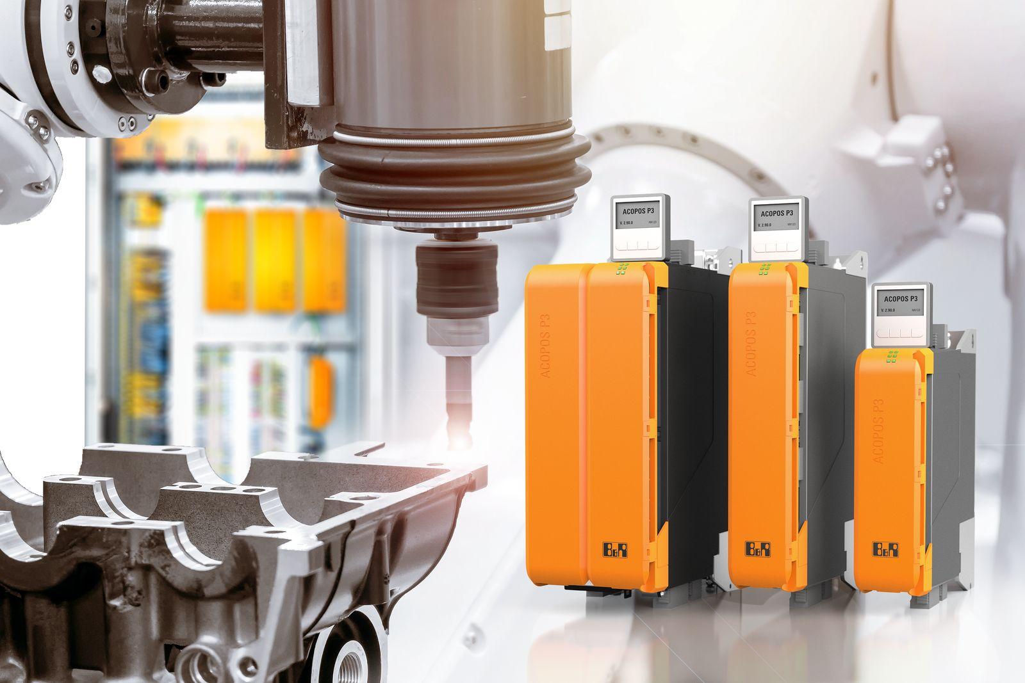
The new ACOPOS P3 servo drive variant is ideally suited for machines with fast rotating axes.

About B&R
B&R is an innovative automation company with headquarters in Austria and offices all around the world. On July 6, 2017, B&R became a business unit of the ABB Group. As a global leader in industrial automation, B&R combines state-of-the-art technology with advanced engineering to provide customers in virtually every industry with complete solutions for machine and factory automation, motion control, HMI and integrated safety technology. With Industrial IoT communication standards like OPC UA, POWERLINK and openSAFETY as well as the powerful Automation Studio software development environment, B&R is constantly redefining the future of automation engineering. The innovative spirit that keeps B&R at the forefront of industrial automation is driven by a commitment to simplifying processes and exceeding customer expectations.
For more information, visit www.br-automation.com.

