More space in the control cabinet
B&R increases machine availability with modular cooling concept for ACOPOS P3
B&R's ACOPOS P3 servo drive is now also available with feed-through heat sink or cold plate cooling. The new cooling solutions dissipate up to 60% of generated heat outside of the control cabinet. This makes it possible to use much more compact cabinets, since fans and air conditioners can be reduced or eliminated entirely. Operation and maintenance costs are reduced.

This new ACOPOS P3 cooling solutions are suitable for a large number of axes in all power ranges. With the elimination of fans and air conditioners that bring outside air into the control cabinet, there is also substantially less dust that gets sucked in along with it. This significantly reduces the need to stop the entire machine for maintenance tasks like replacing air filters. Machine availability goes up.
Compact control cabinet
With feed-through cooling, push-through heat sinks conduct up to 60% of dissipated heat directly to the air outside of the control cabinet. Costly cooling of the control cabinet itself is not necessary. The heat sink offers IP64 protection and is compliant with standards EN 60529 and UL 50 Type 12. The fan installed in the push-through heat sink offers IP54 protection.
Lower costs
Cold plate cooling uses a water-cooled plate to dissipate virtually all heat generated by devices via the coolant. As a result, control cabinets need far fewer fans and climate control units, reducing costs. Cold plate mounting works in conjunction with a machine's own cooling circuit.

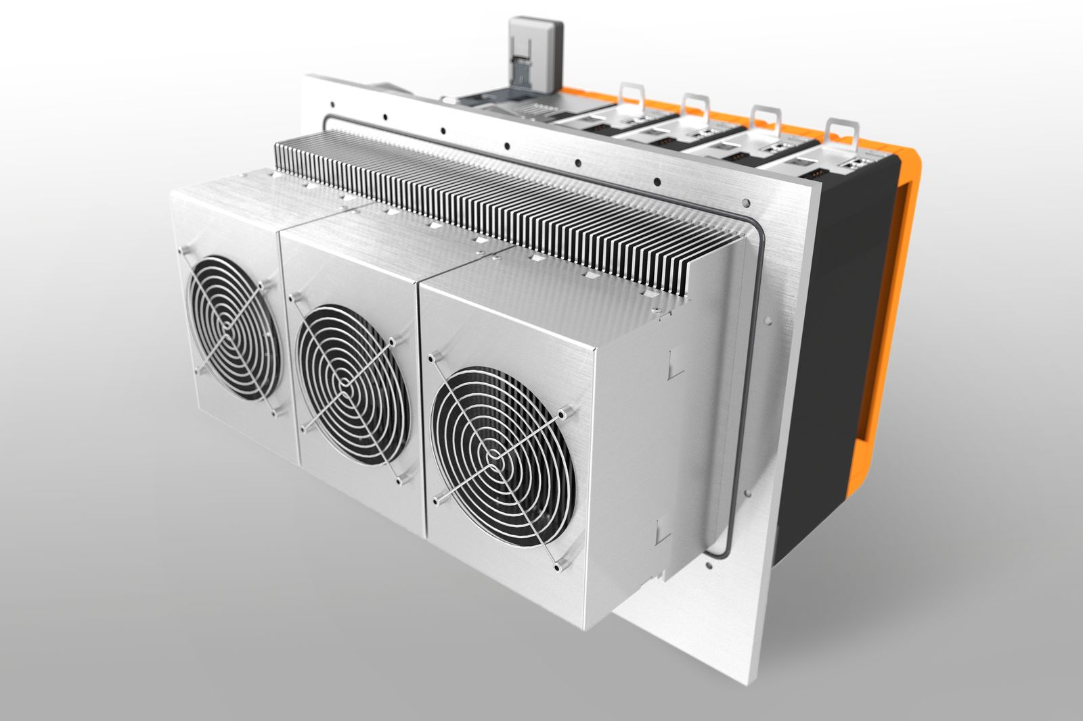
The ACOPOS P3 servo drive is now also available with feed-through heat sink or cold plate cooling. These options allow for a substantially more compact control cabinet design.

About B&R
B&R is an innovative automation company with headquarters in Austria and offices all around the world. On July 6, 2017, B&R became a business unit of the ABB Group. As a global leader in industrial automation, B&R combines state-of-the-art technology with advanced engineering to provide customers in virtually every industry with complete solutions for machine and factory automation, motion control, HMI and integrated safety technology. With Industrial IoT communication standards like OPC UA, POWERLINK and openSAFETY as well as the powerful Automation Studio software development environment, B&R is constantly redefining the future of automation engineering. The innovative spirit that keeps B&R at the forefront of industrial automation is driven by a commitment to simplifying processes and exceeding customer expectations.
For more information, visit www.br-automation.com.

