Optimum lighting for every situation
B&R introduces lighting system for its machine vision solution
B&R’s integrated vision system features innovative lighting components. The flexible light bars and backlights ensure optimum results even in difficult lighting situations. Lighting control is synchronized with the automation system in the sub-µs range.
As integral parts of the automation system, both cameras and lighting are easy to synchronize with other sensors, motor positions and events in the machine application. Lighting control with microsecond precision is even guaranteed when synchronizing multiple cameras and light sources.
Broad spectrum of possibilities
The flexible light bars are available individually or arranged as ring lights in groups of four, six or eight. The backlights are available in two sizes. Each light can feature up to four different LED colors at a time. The selection ranges from white and various visible colors to infrared and ultraviolet. This makes it possible to achieve just the right contrast, color, illumination and intensity for any application.
B&R's light bars feature electronic angle adjustment from -40° to 90°. When producing multiple products on the same machine, the lighting angle can be optimized between batches – once it has been set, it can be saved as part of the batch recipe.
Configuration at runtime
All other lighting parameters can also be configured at runtime to optimize illumination or adapt to new products. Combining LEDs of different colors makes it possible to adjust the wavelength at runtime to optimize contrast.
The eye of the machine
B&R has seamlessly integrated machine vision into its automation system. The portfolio includes intelligent cameras, quality lenses, flexible lighting and powerful image processing algorithms. The high degree of integration can be found at every level of the B&R system, with machine vision fully incorporated into the engineering tool, real time operating system and machine application. Any automation engineer is now able to implement a large portion of machine vision applications on their own.

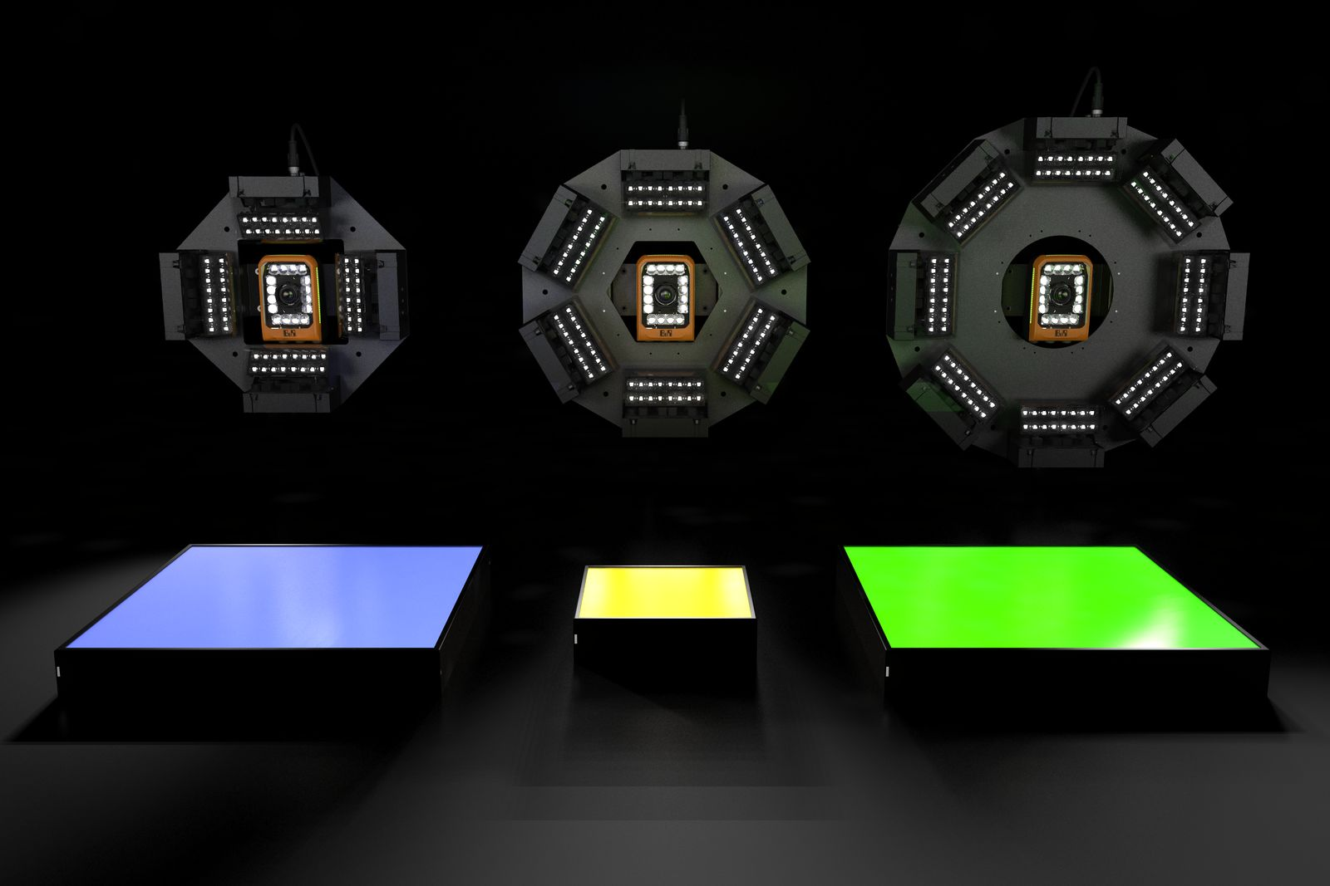
B&R's lighting portfolio includes flexible light bars, backlights and ring lights.

About B&R
B&R, a division of ABB Group, is a global leader in industrial automation headquartered in Austria. B&R combines state-of-the-art technology with advanced engineering to provide customers in virtually every industry with complete solutions for machine and factory automation, motion control, HMI and integrated safety technology. With Industrial IoT communication standards including OPC UA, POWERLINK and openSAFETY as well as its Automation Studio software, B&R is constantly redefining the future of automation engineering. The innovative spirit that keeps B&R at the forefront of industrial automation is driven by a commitment to simplifying processes and exceeding customer expectations.
For more information, visit www.br-automation.com.

